Project Design Phase-I Proposed Solution Template

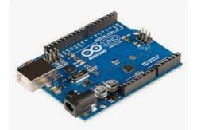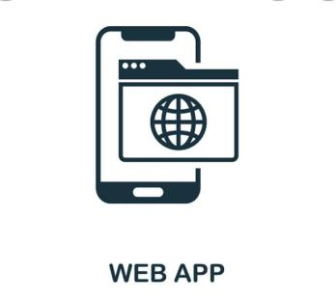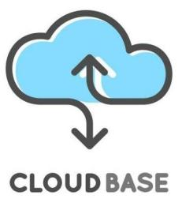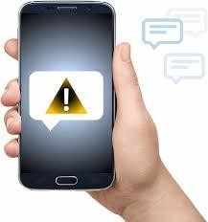

**HARDWARE**

**CLOUD SERVICE**

**USER**

Arduino UNO

END USER

IOT

IBM WATSON

SMS ALERT

(including location)

PYTHON

(Random data)

|  |  |
| --- | --- |
| **Team ID** | PNT2022TMID11781 |
| **Project Name** | Smart Waste Management System For Metropolitan Cities |
| **Maximum Marks** |  |